

**WEB TECHNOLOGIES**

**INFO 2302**

**GROUP MEMBER:**

|  |  |
| --- | --- |
| **NAME** | **MATRIC NO** |
| **NUR FADHILAH AJWA BINTI ROSDEE** | **1815912** |
| **NUR NADIAH BINTI ALI AZMI** | **1813966** |
| **NUR FADHILAH AJWA BINTI ROSDEE** | **1815912** |
| **NUR NADIAH BINTI ALI AZMI** | **1813966** |

Site Map

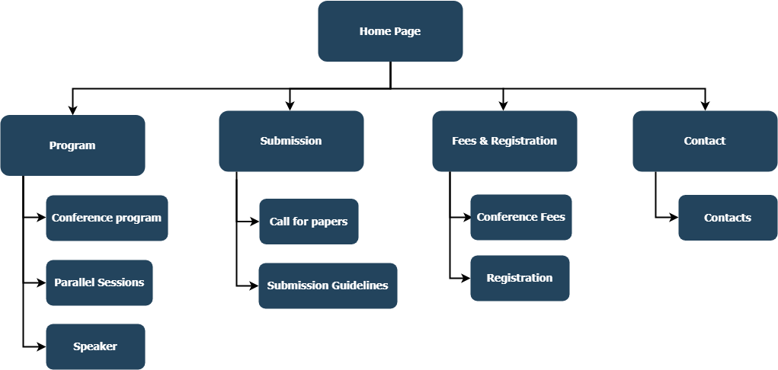

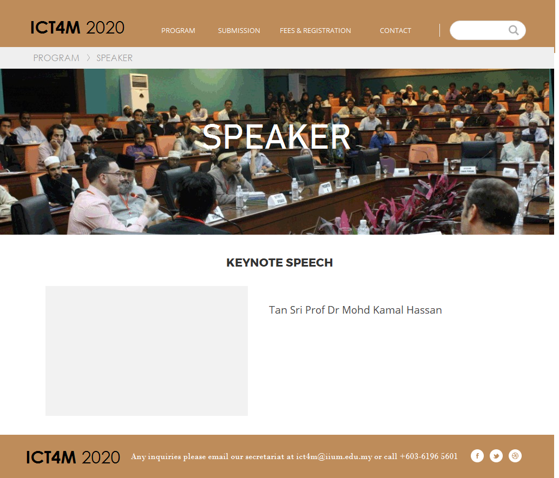

This page will display the picture and details of the speaker.

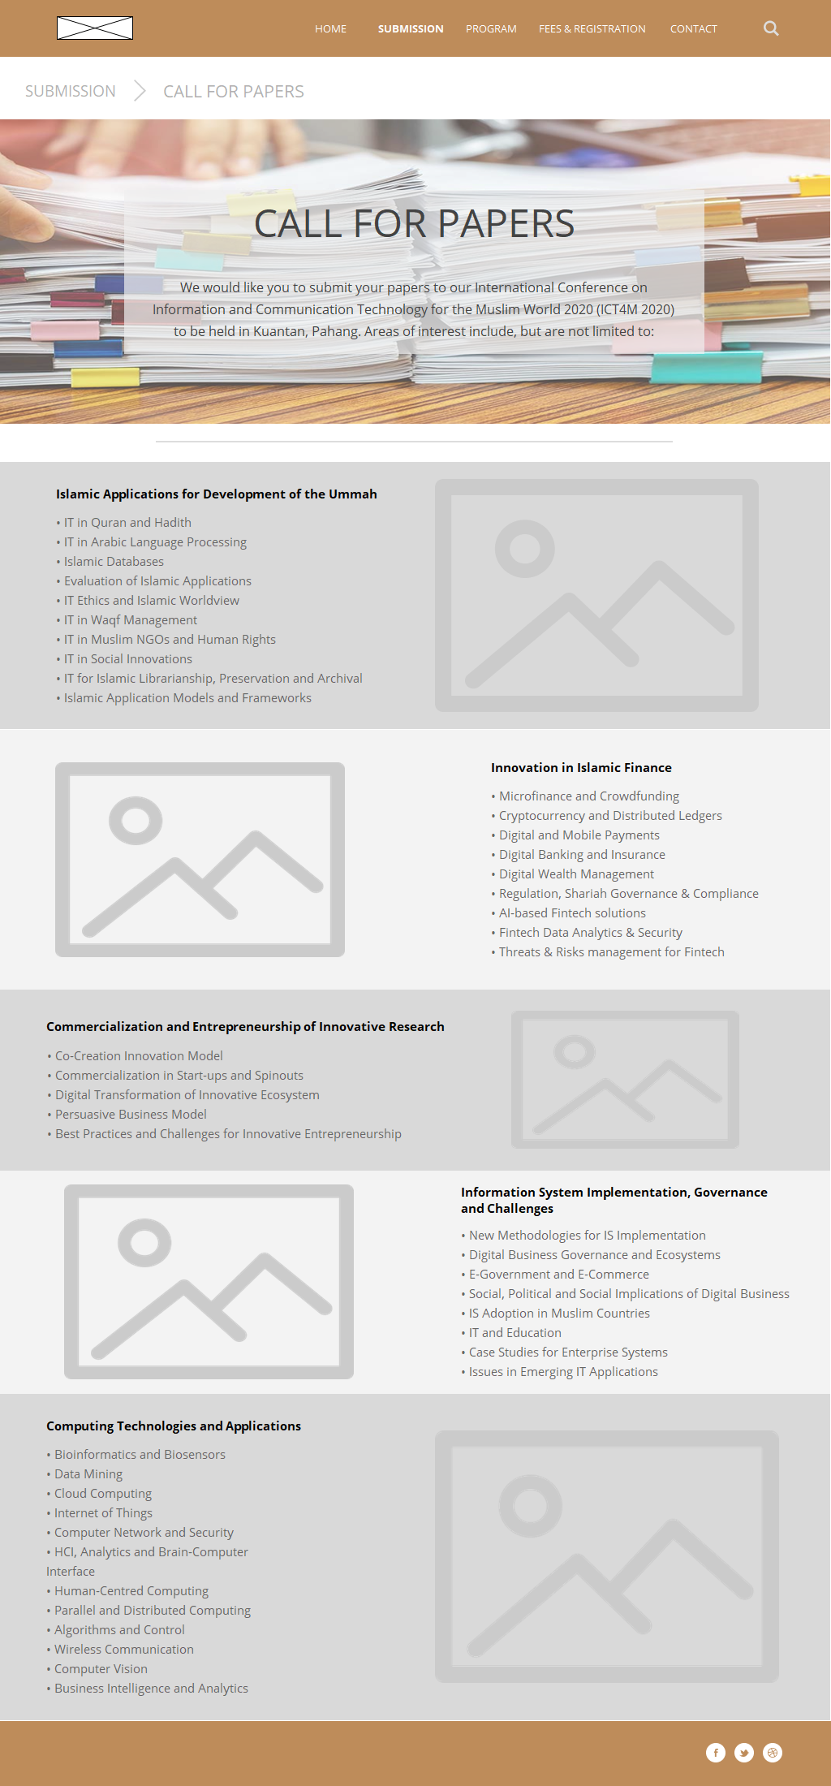

Figure 3 Submission > Call for Papers page

* This paep